Covid-19 Vaccination

Submitted by:

Hassaan Siddiqui SE-19084

Ahmad bin Saud SE-19082

Submitted to:

Dr. Faraz Haider (Assistant Professor at Software Engineering Department, NEDUET)

1. Abstract:

Our aim is to develop a Covid-19 Vaccination website which will be used by the general public to get themselves registered for vaccination. As we are aware of the threat this pandemic is, getting everyone vaccinated is the only effective option right now. This system will provide a user-friendly, reliable and effective way for them to get an appointment. The easier it will be for the people to get vaccinated, the more people would want to. Apart from that this website also provides them with information related to this virus, details about vaccines and procedure, live count for the Covid-19 cases in Pakistan etc. It also provides users with the most frequently asked questions related to the vaccination that will clear all their doubts. The users are asked for their personal as well as their medical history in order to get an appointment. This information is stored in a database which is managed by admin. The admin can review, update, and delete the data from the database.

1. Introduction:

This is an online framework that provide users vaccination appointment with just one click on the submit button after entering their valid information. This framework also keeps a detailed record about the people that got vaccinated which can be used by the government to use. The world is getting smaller as the technology is evolving. Instead of standing in lines waiting and wasting precious time, this system empowers the user to get registered sitting in their homes or offices in a matter of seconds. This will also encourages them to vaccinate themselves and their loved ones and contribute in making this world a better place for everyone. This system also contributes in getting people up to dated with the latest information regarding the pandemic with live counts of covid-19 cases, active cases, recovered, death, critical cases, information regarding covid-19 sop’s and government initiatives. This also helps spreading awareness for people to follow the sops, and to remain safe and healthy.

1. Framework Activities:
   1. Formulation:

Vaccination is a simple, safe and an effective way for protecting people against harmful diseases before they come into contact with them. Especially during the COVID-19 pandemic, vaccination continues to be critically important.

This Online Vaccination System provides general public with the access to the most demanded vaccine all over the world just by registering themselves or their loved ones to our website after meeting the eligibility criteria.

This website will be integrated with a functional data-base at the back-end to hold the information of the people interested in getting them vaccinated. The Information will be kept confidential and secure. Apart from that the users will be able to get enlighten with the information regarding the vaccine, its working mechanism, myths etc. Users can search for the nearest vaccination centers, schedules, and contact information.

The stake holders of this system would be:

* The Authority responsible for carrying out vaccination
* Ministry of National Health Services
* General public
* Medical staff
* National Command Operation Center
  1. Elicitation:

This system assists people who are not familiar with the vaccination procedure in their country as well as in their respective provinces, to get themselves registered for the vaccination in the simplest steps possible.

If a user wants this vaccination service, he/she will have to visit the website and after checking the eligibility criteria and the guidelines, they will have to fill the form with their personal information: Name, Father’s/Husband Name, Date of Birth, City, Home Address, Mobile Number, Emergency Number, Marital Status. They will have to provide with the date for vaccination after going through the schedule available on the website, their medical history, illnesses/allergies and a valid CNIC number.

* + 1. Functional Requirement:
* The system shall allow user to view detail description about the vaccines
* The system must provide a dedicated user interface for registering
* The system must provide a dedicated module for and graphical user interface for the data collection
* The system shall support all the commonly used browsers
* The system shall allow user to enter their personal information
* The system shall allow user to attach their medical history documents
* The system shall notify user upon successful registration process
* The system shall notify user of the unavailability of vaccines
* The system shall allow user to cancel their appointment
* The system shall allow user to reschedule their appointment
* The system shall verify and validate the personal information form
* The system shall not provide access to the data base to any user
* The system shall allow the administration to add, delete of update the records
* The system shall track the quantities of vaccines available
* The administrator will be able to monitor all the actions that occur in the system
  + 1. Non-functional Requirement:
* The system shall protect personal information including the medical history of the user.
* The system shall keep the information confidential
* The database access should be restricted to the administration only
* The system shall store the data after encryption
* The system must be protected from any kind of cyber attacks and unauthorized access
* The system must ask for a “reCAPTCHA” test if any suspicious activity is detected or a change of network
* The system must block any spam advertisements
* The system shall not record information regarding the user without their consent
* The system response for every user interaction must not exceed 2 seconds
* The system must have a simple, user friendly interface that supports all the functionality for the user
* Interface should support all the common browsers, phones with various screen sizes and OS
* The system must maintain correct information all the time
* The system must maintain correct and updated information regarding their policies.
* The system must separate Java code and HTML
* The system must separate the interface from the back-end code
  1. Planning:

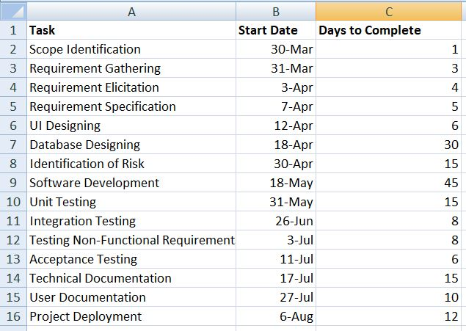

* 1. Modeling:
     1. Use Case Diagram:

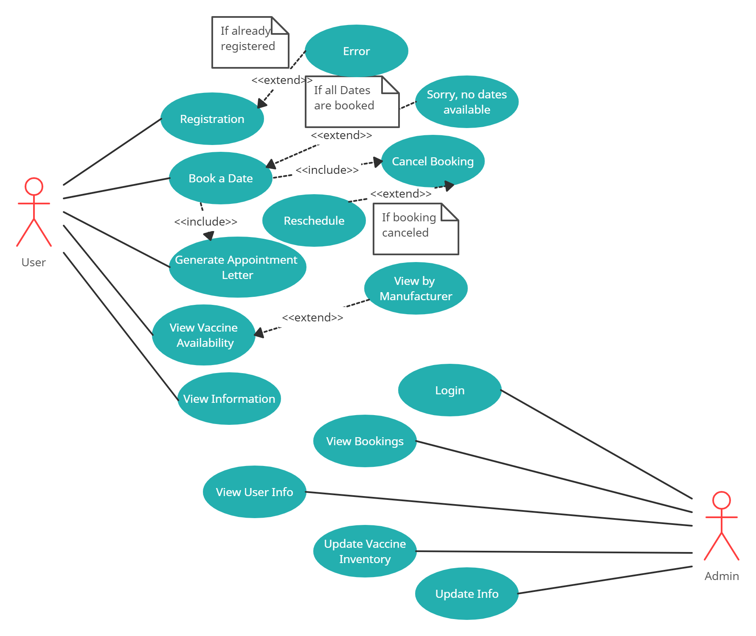

* + 1. Class Diagram:

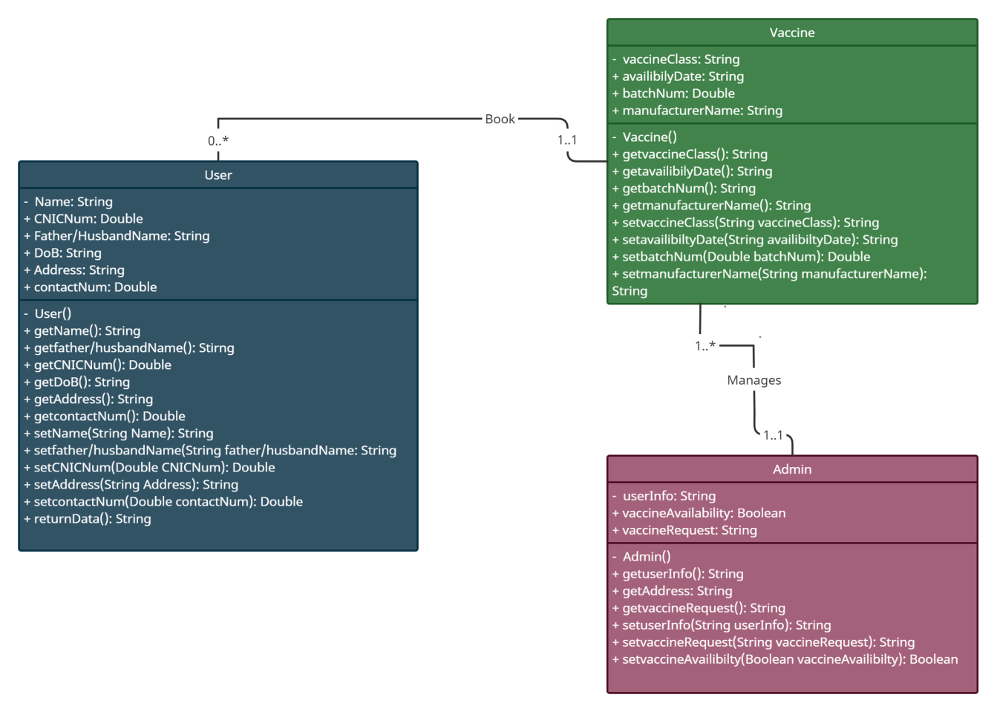

* 1. Construction:

The website is based on HTML 5, CSS 3, JavaScript, JQuery and php. The structure of website is all constructed using HTML which was then given some aesthetics through CSS. The website is also comprised of Bootstrap 5 especially the registration page. Some of the components are reused such as header, navigation bar, footer and the sections. The website is fully dynamic with the use of JavaScript and its libraries to provide a good user experience. There are many animations in the website through CSS to give user many reasons to stay and check out rest of the website. In the back-end, php is used with mySQL database management system using XAMPP server. There are separate php files for the connection and the queries. Two tables are used, one to store the personal information and the other to store medical history of the user. The form contains validation at both front-end and back-end with an interesting front-end validation style using bootstrap validation classes.

Some of the screenshots are attached below for you to visualize the design:

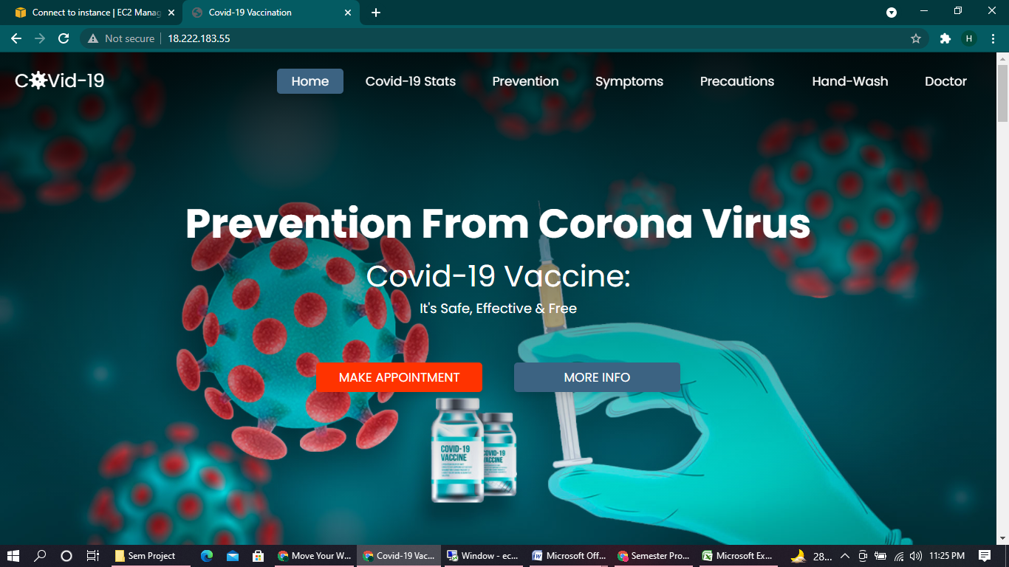 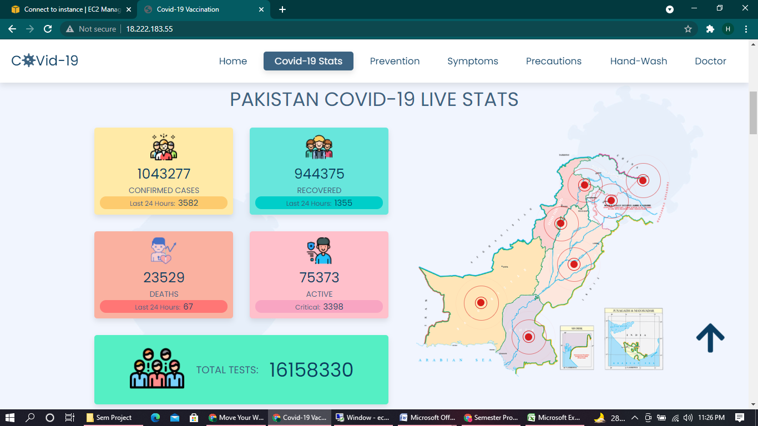

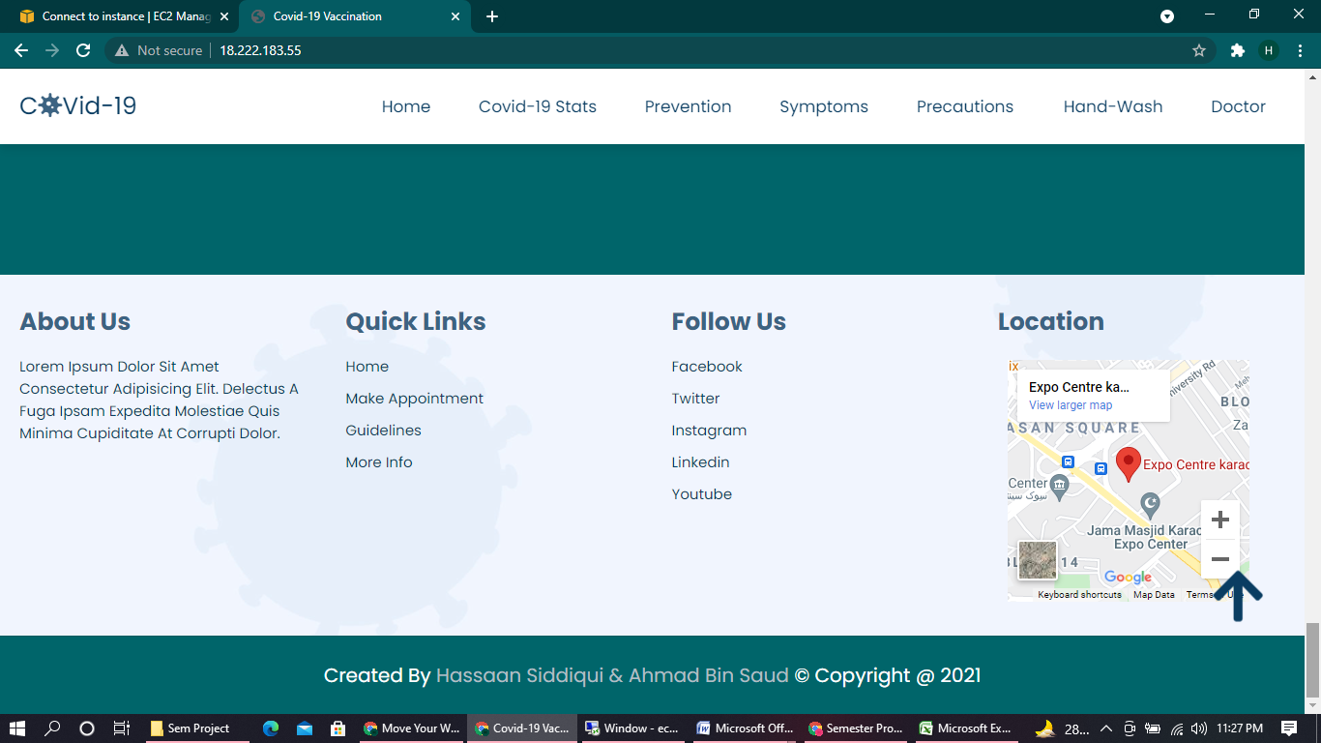 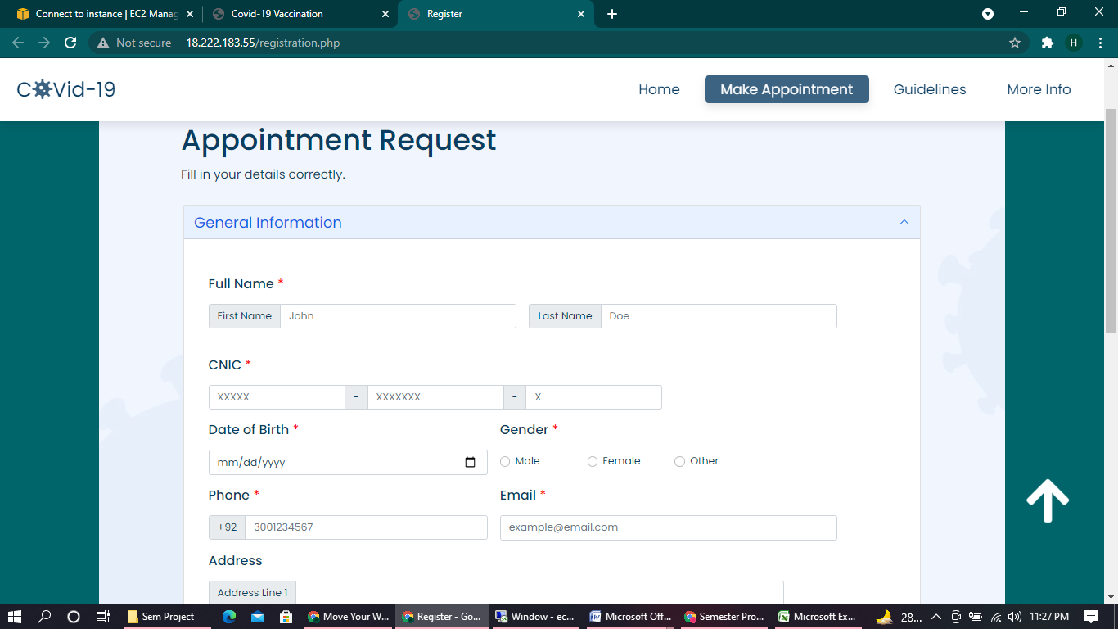

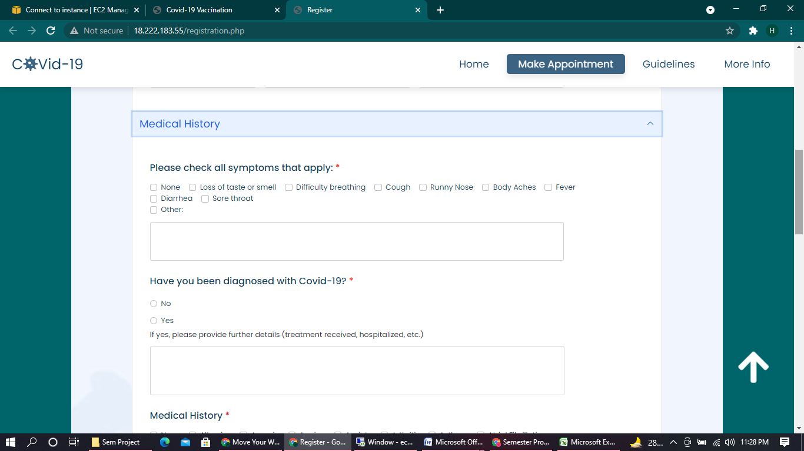 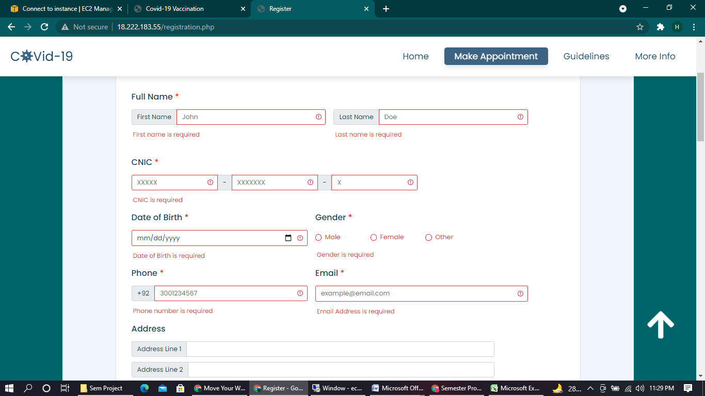

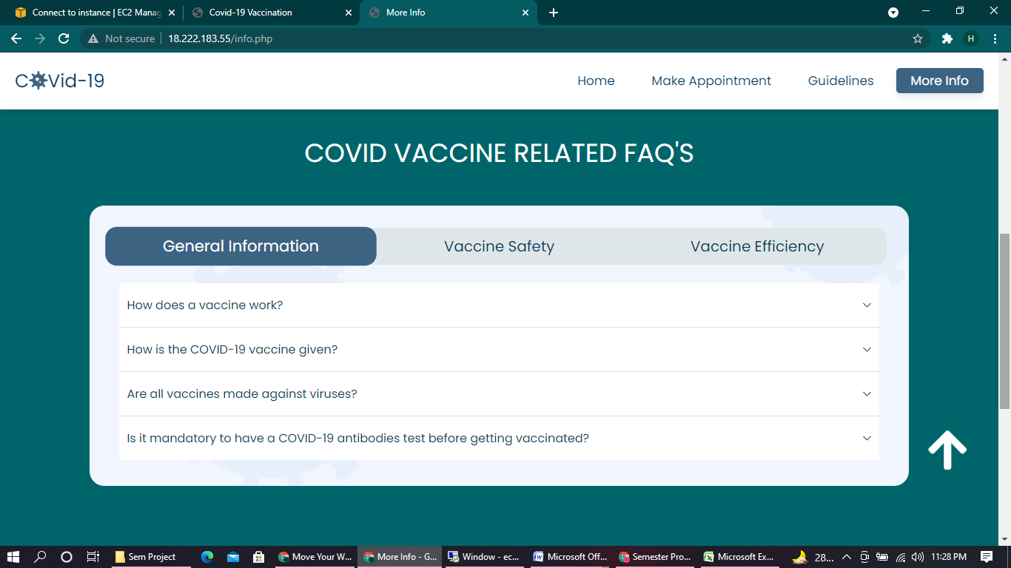

* 1. Deployment:

The last task was to deploy the website by hosting it on a cloud server. The cloud server we used is the Amazon Web Service. Initially the website was hosted on the XAMPP server for testing purposes them we created an EC2 instance on AWS and used it to host our website.

1. Tools & Technologies:
   1. Tools:

* Visual Studio Code
* Google Chrome Browser
  1. Technologies:
* HTML 5
* CSS 3
* JavaScript ES6
* JQuery
* Bootstrap 5
* Php
* MySQL

1. Git Hub Link:

<https://github.com/has-sidd/covid-19.git>

1. Hosting Link:

<http://18.222.183.55/>